Saint John Lutheran Church

We trust God and invite you to experience God’s inclusive love!

Second Sunday of Advent
December 5, 2021 10:00 A.M.
SCHEDULE FOR THE WEEK OF DECEMBER 5

Sunday, December 5 Second Sunday of Advent
10:00 am Worship
11:15 am Drive-by Communion 3:30 pm Online Bible Study with Jill Roy
5:30 pm AA Primary Purpose

Monday, December 6 Offices Closed
7:00 pm AA Primary Purpose
7:00 pm Easy Does It Al-Anon

Tuesday, December 7 7:00 pm AA Primary Purpose

Wednesday, December 8 6:30 pm Worship

Saturday, December 11 5:30 pm AA Primary Purpose

Sunday, December 12 Third Sunday of Advent
10:00 am Worship
11:15 am Drive-by Communion
11:30 am Annual Congregational Meeting, Part 1
12:00 pm Reception for Tidwells and Joan Thomas
3:30 pm Online Bible Study with Jill Roy
5:30 pm AA Primary Purpose

SERVING SAINTS
Reader: Larry Schultz
Ushers: Jill Gates and Julie Gates
Altar Guild: Vaughn and Cheryl Maples
GATHERING

Prelude

Welcome

Please stand

Confession and Forgiveness
All may make the sign of the cross, the sign marked at baptism, as the presiding minister begins.

Blessed be the holy Trinity, ☩ one God, who alone does wonders, who lifts up the lowly, who fills the hungry with good things. Amen.

Let us confess our sin, trusting in the tender mercy of our God.

Silence is kept for reflection.

God for whom we wait,
in the presence of one another, we confess our sin before you. We fail in believing that your good news is for us. We falter in our call to tend your creation. We find our sense of self in material wealth. We fear those different from ourselves. We forget that we are your children and turn away from your love. Forgive us, Blessed One, and assure us again of your saving grace.
Amen.

God, in Christ Jesus, has looked with favor upon you! Through the power of the Holy Spirit, ☩ your sins are forgiven. You are children of the Most High,
inheritors of the eternal promise, and recipients of divine mercy.
God strengthens you anew to follow the way of peace. Amen.

Our mission here at St. John is…
We trust God and invite you to experience God’s inclusive Love!

Gathering Song Prepare the Royal Highway (page 12)

Greeting
The grace of our Lord Jesus Christ, the love of God, and the Communion of the Holy Spirit be with you all. And also with you.

Kyrie (page 13 & 14)

The Prayer of the Day
Stir up our hearts, Lord God, to prepare the way of your only Son. By his coming strengthen us to serve you with purified lives; through Jesus Christ, our Savior and Lord, who lives and reigns with you and the Holy Spirit, one God, now and forever. Amen.

Please be seated

Lighting of Advent Wreath (Verse 2)
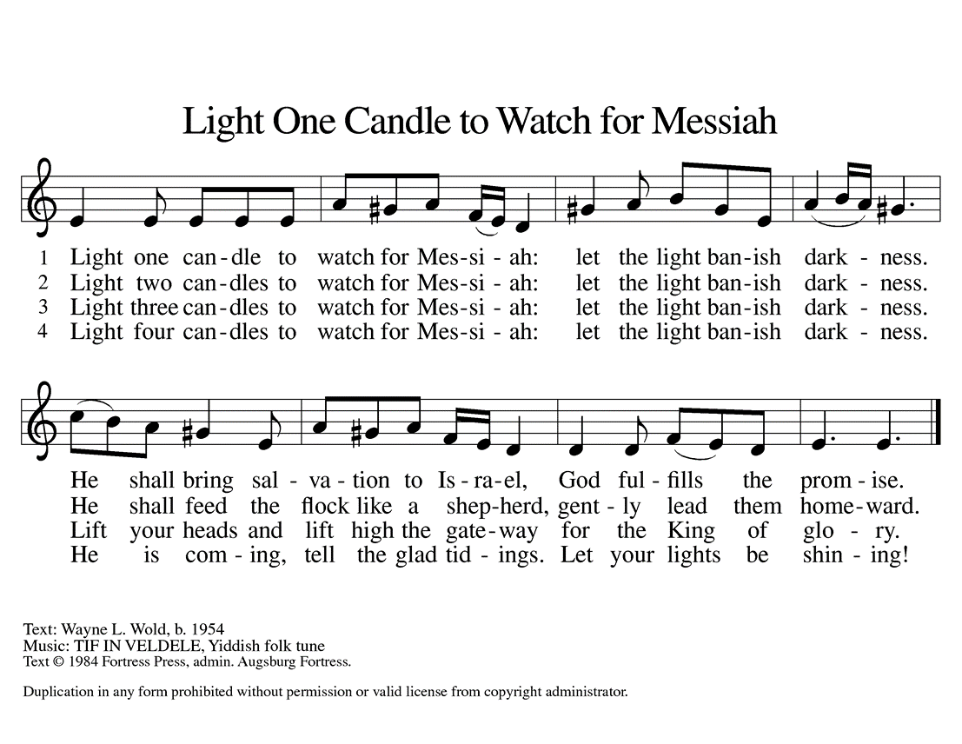

WORD

Malachi 3:1-4
¹See, I am sending my messenger to prepare the way before me, and the Lord whom you seek will suddenly come to his temple. The messenger of the covenant in whom you delight—indeed, he is coming, says the Lord of hosts. ²But who can endure the day of his coming, and who can stand when he appears?
For he is like a refiner’s fire and like fullers’ soap; ³he will sit as a refiner and purifier of silver, and he will purify the descendants of Levi and refine them like gold and silver, until they present offerings to the Lord in righteousness. ⁴Then the offering of Judah and Jerusalem will be pleasing to the Lord as in the days of old and as in former years.

Word of God, word of life. Thanks be to God

Luke 1:68-79
⁶⁸Blessed are you, Lord, the God of Israel,
you have come to your people and set them free.
⁶⁹You have raised up for us a mighty Savior,
born of the house of your servant David.
⁷⁰Through your holy prophets, you promised of old to save us from our enemies,
⁷¹from the hands of all who hate us,
⁷²to show mercy to our forebears,
and to remember your holy covenant.
⁷³This was the oath you swore to our father Abraham:
⁷⁴to set us free from the hands of our enemies,
free to worship you without fear,
⁷⁵holy and righteous before you, all the days of our life.
⁷⁶And you, child, shall be called the prophet of the Most High,
for you will go before the Lord to prepare the way,
⁷⁷to give God’s people knowledge of salvation
by the forgiveness of their sins.
⁷⁸In the tender compassion of our God
the dawn from on high shall break upon us,
⁷⁹to shine on those who dwell in darkness and in the shadow of death,
and to guide our feet into the way of peace.

Philippians 1:3-11
³I thank my God every time I remember you, ⁴constantly praying with joy in every one of my prayers for all of you, ⁵because of your sharing in the gospel from the first day until now. ⁶I am confident of this, that the one who began a good work among you will bring it to completion by the day of Jesus Christ. ⁷It is right for me to think this way about all of you, because you hold me in your heart, for all of you share in God’s grace with me, both in my imprisonment and in the defense and confirmation of the gospel. ⁸For God is my witness, how I long for all of you with the compassion of Christ Jesus. ⁹And this is my prayer, that your love may overflow more and more with knowledge and full insight ¹⁰to help you to determine what is best, so that in the day of Christ you may be pure and blameless, ¹¹having produced the harvest of righteousness that comes through Jesus Christ for the glory and praise of God.

Word of God, word of life. Thanks be to God.

Please stand

Gospel Acclamation 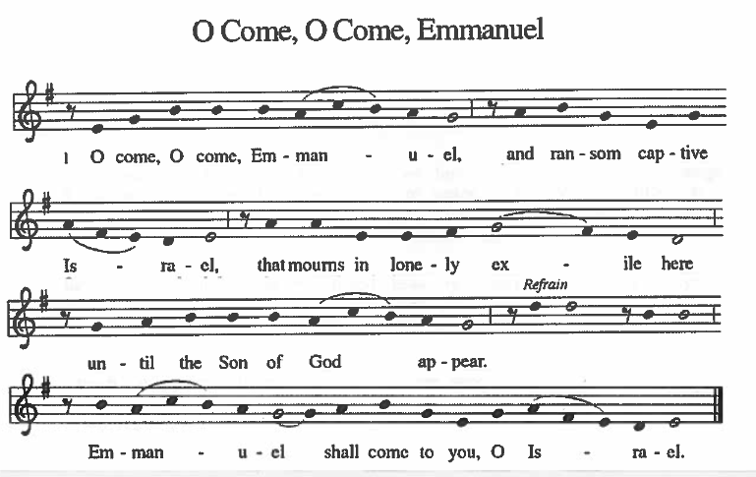

The Holy Gospel according to Luke. Glory to you, O Lord.

Luke 3:1-6
¹In the fifteenth year of the reign of Emperor Tiberius, when Pontius Pilate was governor of Judea, and Herod was ruler of Galilee, and his brother Philip ruler of the region of Ituraea and Trachonitis, and Lysanias ruler of Abilene, ²during the high priesthood of Annas and Caiaphas, the word of God came to John son of Zechariah in the wilderness. ³He went into all the region around the Jordan, proclaiming a baptism of repentance for the forgiveness of sins, ⁴as it is written in the book of the words of the prophet Isaiah,
“The voice of one crying out in the wilderness:
‘Prepare the way of the Lord,
make his paths straight.
⁵Every valley shall be filled,
and every mountain and hill shall be made low,
and the crooked shall be made straight,
and the rough ways made smooth;
⁶and all flesh shall see the salvation of God.’ ”

The Gospel of the Lord. Praise to you, O Christ.

Sermon

Silence is kept for reflection

Hymn of the Day On Jordan’s Bank the Baptist’s Cry (page 15)

Apostles’ Creed
I believe in God, the Father almighty,
creator of heaven and earth.

I believe in Jesus Christ, God’s only Son, our Lord,
who was conceived by the Holy Spirit,
born of the virgin Mary,
suffered under Pontius Pilate,
was crucified, died, and was buried;
he descended to the dead.
On the third day he rose again;
he ascended into heaven,
he is seated at the right hand of the Father,
and he will come to judge the living and the dead.

I believe in the Holy Spirit,
the holy catholic Church,
the communion of saints,
the forgiveness of sins,
the resurrection of the body,
and the life everlasting. Amen

Prayers of Intercession
You send messengers into the world to proclaim the day of your coming. Make our bishops, pastors, deacons, and lay preachers confident in their preaching, that their words and our lives witness to your grace. Bless the ministry of Agustinian Lutheran School, Guatemala and St. Johannes, Bavaria. We pray for Grace Missions and Chez Moi Orphanage, Haiti. Hear us, O God. Your mercy is great.

Send leaders to our nations, cities, schools, and businesses to work on behalf of those who have lost parents, spouses, and loved ones; immigrants; the imprisoned; those living in poverty; and all who are oppressed. Make them bold in their commitments to justice and reconciliation. We pray for protection of those who serve in the military, especially Chantz Roche and Sequoya McLendon.
Hear us, O God. Your mercy is great.

Send your servants to care for those who suffer. Use our ministries and our lives to reach out with compassion to those who are hungry, oppressed, lonely, or ill, especially, Cathleen Dahl, Charlie Parks, William Panick, Bob Keener, Susan and David Friend, Maureen Caldwell, April Kennedy, Andy and June Harnack, John Bennett, Sarah Lanier, Catherine Campbell, Terry Emlet, Bill Tidwell, Marcus Loner, Charlie Norman, Gary Larson, Kay Pedrotti, Janet Kindred and family. Grant them healing and wholeness. Hear us, O God. Your mercy is great.

Bless those celebrating birthdays, Heather McVey; those celebrating baptisms, Jennifer Durham, Forrest Durham; and expectant parents, Heather and Marcus Loner. Hear us, O God. Your mercy is great.

We lift up all others we name in our hearts or on our lips….. (Pause).
Hear us, O God. Your mercy is great.

God of new life, you come among us in the places we least expect. Receive these prayers and those of our hearts, in the name of Jesus.
Amen.

MEAL

Offering Hymn Give Thanks (bulletin page 16)

Offering Prayer
God of our waiting and watching, we offer the gifts of our hearts and our lives
to the service of all your people. Prepare the way before us as we meet you in this simple meal, through Christ Jesus, our pathway and our peace. Amen.

The Great Thanksgiving
The Lord be with you.
And also with you.
Lift up your hearts.
We lift them to the Lord.
Let us give thanks to the Lord our God.
It is right to give our thanks and praise.

Eucharistic Prayer
Holy God, mighty Lord, gracious Father:
Endless is your mercy and eternal your reign.
You have filled all creation with light and life;
heaven and earth are full of your glory.
Through Abraham and Sarah you promised to bless all nations.
You rescued Israel, your chosen people.

Through the prophets you renewed your promise;
and, at this end of all the ages, you sent your Son,
who in words and deeds proclaimed your kingdom
and was obedient to your will, even to giving his life.

In the night in which he was betrayed,
our Lord Jesus took bread, and gave thanks;
broke it, and gave it to his disciples, saying:
Take and eat; this is my body, given for you.
Do this for the remembrance of me.

Again, after supper, he took the cup, gave thanks,
and gave it for all to drink, saying:
This cup is the new covenant in my blood,
shed for you and for all people for the forgiveness of sin.
Do this for the remembrance of me.

For as often as we eat of this bread and drink from this cup
we proclaim the Lord's death until he comes.
Christ has died. Christ is risen. Christ will come again.

Therefore, gracious Father, with this bread and cup
we remember the life our Lord offered for us.
And, believing the witness of his resurrection, we await his coming
in power to share with us the great and promised feast.
Amen. Come, Lord Jesus.

Lord, remember us in your kingdom and teach us to pray:
Our Father, who art in heaven,
hallowed be thy name,
thy kingdom come, thy will be done,
on earth as it is in heaven
Give us this day our daily bread;
and forgive us our trespasses,
as we forgive those who trespass against us;
and lead us not into temptation,
but deliver us from evil.
For thine is the kingdom,
and the power, and the glory, forever and ever. Amen

SENDING

Announcements

Benediction
People of God, you are Christ’s body, bringing new life to a suffering world.
The holy Trinity, ☩ one God, bless you now and forever. Amen.

Sending Hymn Come, Thou Long-Expected Jesus (page 17)

Peace of the Lord

Invitation to Communion
All who hunger and thirst, come.
The table is ready.

Dismissal
As we go on our way, let us remember…
Through Jesus Christ, we are an equipping and responding church
that continues to grow, impact, and transform lives.
Go in Peace, May the Holy Spirit guide you. Thanks be to God!

Communion
Communion will begin in front of the altar. You may dispose of your cup in the waste basket outside the nave. We ask that you leave the sanctuary after taking communion.

The offering plate and noisy change bucket located outside the nave.
The congregation is encouraged to sing during the distribution:
By Your Hand You Feed Your People (page 18)
Around You, O Lord Jesus (page 19)
Kyrie
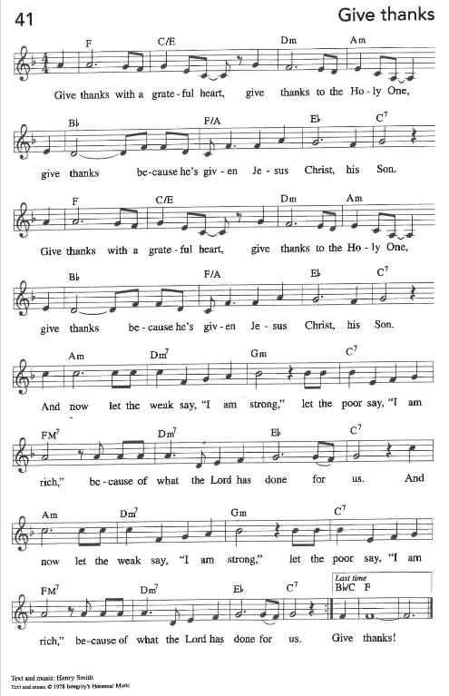

IN OUR PRAYERS THIS WEEK – DECEMBER 5, 2021
Cathleen Dahl, Charlie Parks, William Panick, Bob Keener, Susan and David Friend, Maureen Caldwell, April Kennedy, Andy and June Harnack, John Bennett, Sarah Lanier, Catherine Campbell, Terry Emlet, Bill Tidwell, Olga Fields, Marcus Loner, Charlie Norman, Gary Larson, Kay Pedrotti.

BIRTHDAYS BAPTISMS
12/6 Heather McVey 12/5 Jennifer Durham
EXPENTANT PARENTS 12/5 Forrest Durham
Heather and Marcus Loner MILITARY
Sequoya McLendon, Chantz Roche

Family and Friends: Liz and Bob Sherliza, Deb Tutson, Claudette Gallman, (Friends of Saint John); Jennifer Jones and Kyle (friends of Amy Droegmiller), Haley Olinger (friend of Terry Emlet);Ruby Reid (family of Gwen Flowers-Taylor); Brian and Shiy (family of Steve and Sandra Harwood); Charles Harper, Tim Kennedy (family and friends of April Kennedy); Nancy Osteen, family of Joel Puzder (friends of Janet Kindred); Kim Lothrop, (family of Connie Klopfenstein); Brian, Susan St. John, Deborah Lanier, Scott and Kimberly Lanier (family and friends of Sarah Lanier); Isaac Russell (family of Marcus Loner); Richard and Sue Tomsovic, (Uncle & Aunt of Tish Martin); Melissa Roy, Mary Donna Harris (family of Jill Roy); Doug Maxwell, (Brother of Debbie Sakmar); Whitney O’Connor Hawk (granddaughter of Larry Schultz); Helen Carter (family of Peggy Thomas), Jeanie Tidwell (mother of Bill, Tidwell); Ron and Kathy Ballek (brother and sister-in-law of Sharon Willard).

MASKS
While masks are not required in the building, we strongly urge you to wear one. We also ask that you maintain social distancing.

BAGS NEEDED
Plastic grocery bags are needed for the mat weaving class. If you have extra bags, please consider donating them. We are especially looking for colorful bags, but will take any color. All mats are donated to the homeless.

ITEMS NEEDED FOR CHRISTMAS BAGS
The elves are ready and now we need your help with some items for a little gift bag for those in need in our community. We could use the following items: travel sized soap, shampoo, and hand lotion, gloves and combs. Please bring them to church no later than December 12th. We will be preparing the bags on the 16th.
A box will be in the narthex to collect these items. Thanks for helping us reach out to those in need in our community this Christmas. See Pastor Mary if you have any questions.

Help needed for Worship on Christmas Eve, December 26th and January 2nd!
Christmas Eve services will be held on Friday, December 24th at 7 p.m. In order to plan ahead, we need help for that service as well as December 26th, and January 2nd. Please see the sign-up sheets, and sign up where you can help. If you are new to helping, we will make sure to provide you training.

December Cracklin and change bucket- Youth ministry
Our December Cracklin and change bucket will go to help our children and youth attend summer camp or Affirm, in the summer of 2022. Thanks for your support all year for the bucket. Your change really makes a difference, and we thank you so much!

Wednesday Evening Advent services- 6:30 p.m.
Please join us in person or online for Holden Evening service and devotions.

ANNUAL CONGREGATIONAL MEETING
Dear Voting Member(s) of Saint John Lutheran Church,

The annual meeting of the congregation will be held on Sunday, December 12, 2021,
at 11:30 am, in the Fellowship Hall. The meeting will be followed by a reception for Bill
and Cherie Tidwell and Joan Thomas.

The following business will be conducted:
- Review and adopt the proposed budget for 2022 – the budget is enclosed.
- Elect the 2022 Nominating Committee
- Elect voting members to the Congregation Council to fill a 3-year term.
The Nominating Committee recommends the following: Vaughn Maples.
- Elect two voting members (one male, one female) to the Southeastern Synod Assembly, June 5. The Nominating Committee recommends Don Taylor and Gwen Flowers-Taylor.

The meeting will adjourn in continued session and reconvene on Sunday, January 23, 2022, at 11:30 am, to receive annual reports from officers and committees.

All voting members are encouraged to attend these meetings. The Constitution defines voting members as “confirmed members who have communed and made a contribution of record during the current or preceding year.”

God has richly blessed us with an abundance of gifts, and the Holy Spirit is equipping and sending us to do God’s Work with Our Hands.

In Christ,
Don Taylor, President

Synod Advent devotions
Luke 13:31-35
How often I’ve longed to gather your children,
gather your children like a hen,
Her brood safe under her wings—
but you refused and turned away!

In this passage, Jesus is warned to flee because Herod is after him. But Jesus shares that he is busy healing others and clearing out the demons as Jesus is wrapping things up. Then Jesus laments his relationship with Jerusalem and her people. He shares from his heart that he so wants to gather the people of Israel and protect them like a hen who gathers her children under her wing.

How often do we read this passage and miss that Jesus is comparing his care and protection for God’s people to a female animal who is known for her love of her babies? I relate to this passage as a farm girl who had the chore of feeding our chickens and collecting the eggs throughout my growing up in Illinois. I saw the care that the hens gave to their little ones. How comforting to know that Jesus wants to take care of God’s children in such a warm and caring way.

In this season, there are many parents who wish they could care for their children, and adult children who wish to care for their elderly parents but may not be able to for any number of reasons. It could be anything from living a long distance away to being short on funds, and everything in between. As Christians, we have been given the sacred work of being Christ’s hands, feet, and care on this earth.

There are many ways you can reach out and be of comfort to others. You can reach out to friends and church members who are alone this time of year to send a card, say a prayer, or spend time with them. You can help foster children, adults with special needs, and new immigrants to our area by providing coats or gift cards this season. (www.weinspirit.org) You can visit a nursing home or volunteer at a senior center near you. You can give a gift of chicks, pigs, or fill a backpack with food for a child in need through the ELCA good gifts catalog. (www.goodgifts.elca.org)

Whatever you decide to do, remember that you are bringing God’s love and comfort to those who need some extra care this season. Also, may those of you reading this who need to know God’s comfort this season receive it in a real and tangible way!

Saint John Lutheran Church
1689 Martin Luther King Jr. Parkway
Griffin, GA 30224
Church Phone: 770-228-0662
Email: stjohnelca@bellsouth.net
Website: www.stjohngriffin.org
Facebook: Saint John Evangelical Lutheran Church
Pastor Mary Armstrong-Reiner
Pastor_st.john@yahoo.com
Cell 309-212-0888

Support Staff
Lynn Jones, Administrative Assistant Amy Droegmiller, Youth Leader
Marilyn Droegmiller, Organist Gayle Harvil, Praise Team Director
Joan Thomas, Choir Director Heather Loner, Nursery Attendant
Jennifer Durham, Choir Accompanist

Congregation Council
Don Taylor, President Todd Droegmiller Enid Mswia
Bailey Harvil, Vice-President Phyllis Hutchings Russ Rines
Catherine Park, Secretary Rita Johnson Sarah Sanders
Tish Martin, Treasurer Donna Milam
Mark Miller

Ministry Contacts
Altar Guild: Sandra Harwood Member Care: Sarah Lanier, Cherie Tidwell
Education: Phyllis Hutchings Property: John Sanders
Fellowship: Laura Miller, Martha Dansby Social Ministry: Jill Gates, Don Taylor
Finance: Tish Martin Stewardship: Mark Miller
Gifts and Memorials: Tish Martin Worship: Sandra Harwood
Glocal Mission: Larry Schultz Youth/Children’s Ministry: Amy Droegmiller

All liturgies, prayers, Bible passages and music are reprinted with permission from the following resources.
Augsburg Fortress Liturgies Annual License 23384;
OneLicense.net. License #A-701923; CCLI License # 2725291 & 20964660.
OneLicense.net. License #A-701923; CCLI License # 2725291.

