Saint John Lutheran Church

We trust God and invite you to experience God’s inclusive love!

Second Sunday after Epiphany
January 16, 2022 10:00 A.M.

SCHEDULE FOR THE WEEK OF January 16

Sunday, January 16 Second Sunday after Epiphany
10:00 am Worship
11:30 am Council 3:30 pm Online Bible Study with Jill Roy
5:30 pm AA Primary Purpose

Monday, January 17 Office Closed
7:00 pm AA Primary Purpose
7:00 pm Easy Does It Al-Anon

Tuesday, January 18 Office Closed
7:00 pm AA Primary Purpose

Saturday, January 22 5:30 pm AA Primary Purpose

Sunday, January 23 Third Sunday after Epiphany
10:00 am Worship
11:15 am Drive-by Communion
11:30 am Congregational Meeting, Part 2 3:30 pm Online Bible Study with Jill Roy
5:30 pm AA Primary Purpose

GATHERING

Prelude

Welcome

Confession and Forgiveness
All may make the sign of the cross, the sign that is marked at baptism, as the presiding minister begins.

Blessed be the holy Trinity, ☩ one God, who creates us, redeems us, and calls us by name. Amen.

Let us confess our sin in the presence of God and of one another.
Silence is kept for reflection.

Most merciful God, we confess that we have sinned against you and your beloved children. We have turned our faces away from your glory when it did not appear as we expected. We have rejected your word when it made us confront ourselves. We have failed to show hospitality to those you called us to welcome. Accept our repentance for the things we have done and the things we have left undone. For the sake of Jesus Christ, have mercy on us. Forgive us and lead us, that we may bathe in the glory of your Son born among us, and reflect your love for all creation. Amen.

Rejoice in this good news: In ☩ Christ Jesus, your sins are forgiven. You are descendants of the Most High, adopted into the household of Christ, and inheritors of eternal life. Live as freed and forgiven children of God. Amen.

Our mission here at St. John is…
We trust God and invite you to experience God’s inclusive Love!

Gathering Song Drawn to the Light (Page 11)

Greeting
The grace of our Lord Jesus Christ, the love of God, and the Communion of the Holy Spirit be with you all. And also with you.

Kyrie (Page 12)

The Prayer of the Day
Lord God, source of every blessing, you showed forth your glory and led many to faith by the works of your Son, who brought gladness and salvation to his people. Transform us by the Spirit of his love, that we may find our life together in him, Jesus Christ, our Savior and Lord. Amen.

Please be seated

WORD

Isaiah 62:1-5
¹For Zion’s sake I will not keep silent,
and for Jerusalem’s sake I will not rest,
until her vindication shines out like the dawn,
and her salvation like a burning torch.
²The nations shall see your vindication,
and all the kings your glory;
and you shall be called by a new name
that the mouth of the Lord will give.
³You shall be a crown of beauty in the hand of the Lord,
and a royal diadem in the hand of your God.
⁴You shall no more be termed Forsaken,
and your land shall no more be termed Desolate;
but you shall be called My Delight Is in Her,
and your land Married;
for the Lord delights in you,
and your land shall be married.
⁵For as a young man marries a young woman,
so shall your builder marry you,
and as the bridegroom rejoices over the bride,
so shall your God rejoice over you.

Word of God, word of life. Thanks be to God

Psalm 36:5-10
⁵Your love, O Lord, reaches to the heavens,
and your faithfulness to the clouds.
⁶Your righteousness is like the strong mountains, your justice like the great deep;
you save humankind and animals, O Lord.
⁷How priceless is your love, O God!
All people take refuge under the shadow of your wings.
⁸They feast upon the abundance of your house;
you give them drink from the river of your delights.
⁹For with you is the well of life,
and in your light we see light.
¹⁰Continue your lovingkindness to those who know you,
and your favor to those who are true of heart.

1 Corinthians 12:1-11
¹Now concerning spiritual gifts, brothers and sisters, I do not want you to be uninformed. ²You know that when you were pagans, you were enticed and led astray to idols that could not speak. ³Therefore I want you to understand that no one speaking by the Spirit of God ever says “Let Jesus be cursed!” and no one can say “Jesus is Lord” except by the Holy Spirit.
⁴Now there are varieties of gifts, but the same Spirit; ⁵and there are varieties of services, but the same Lord; ⁶and there are varieties of activities, but it is the same God who activates all of them in everyone. ⁷To each is given the manifestation of the Spirit for the common good. ⁸To one is given through the Spirit the utterance of wisdom, and to another the utterance of knowledge according to the same Spirit, ⁹to another faith by the same Spirit, to another gifts of healing by the one Spirit, ¹⁰to another the working of miracles, to another prophecy, to another the discernment of spirits, to another various kinds of tongues, to another the interpretation of tongues. ¹¹All these are activated by one and the same Spirit, who allots to each one individually just as the Spirit chooses.

Word of God, word of life. Thanks be to God.

Gospel Acclamation
The Holy Gospel according to John. Glory to you, O Lord.

John 2:1-11
¹On the third day there was a wedding in Cana of Galilee, and the mother of Jesus was there. ²Jesus and his disciples had also been invited to the wedding. ³When the wine gave out, the mother of Jesus said to him, “They have no wine.” ⁴And Jesus said to her, “Woman, what concern is that to you and to me? My hour has not yet come.” ⁵His mother said to the servants, “Do whatever he tells you.” ⁶Now standing there were six stone water jars for the Jewish rites of purification, each holding twenty or thirty gallons. ⁷Jesus said to them, “Fill the jars with water.” And they filled them up to the brim. ⁸He said to them, “Now draw some out, and take it to the chief steward.” So they took it. ⁹When the steward tasted the water that had become wine, and did not know where it came from (though the servants who had drawn the water knew), the steward called the bridegroom ¹⁰and said to him, “Everyone serves the good wine first, and then the inferior wine after the guests have become drunk. But you have kept the good wine until now.” ¹¹Jesus did this, the first of his signs, in Cana of Galilee, and revealed his glory; and his disciples believed in him.

The Gospel of the Lord. Praise to you, O Christ.

Sermon

Silence is kept for reflection

Hymn of the Day Shine, Jesus, Shine (Page 13)

Apostles’ Creed
I believe in God, the Father almighty,
creator of heaven and earth.

I believe in Jesus Christ, God’s only Son, our Lord,
who was conceived by the Holy Spirit,
born of the virgin Mary,
suffered under Pontius Pilate,
was crucified, died, and was buried;
he descended to the dead.
On the third day he rose again;
he ascended into heaven,
he is seated at the right hand of the Father,
and he will come to judge the living and the dead.

I believe in the Holy Spirit,
the holy catholic Church,
the communion of saints,
the forgiveness of sins,
the resurrection of the body,
and the life everlasting. Amen

Prayers of Intercession
The Spirit of the Lord is poured out upon us in abundance; so we are bold to pray for the church, the world, and all that God has made.

A brief silence.

By your Spirit, activate within your church gifts of faith, healing, and prophecy. Unite those who profess your name across congregations, denominations, and geographic boundaries. Open our hearts to recognize and celebrate surprising miracles. Bless the ministry of Agustinian Lutheran School, Guatemala and St. Johannes, Bavaria. We pray for Grace Missions and Chez Moi Orphanage, Haiti.
God of grace, hear our prayer.

By your Spirit, grant wisdom, knowledge, and discernment to those who hold leadership positions at any level. Direct policymakers toward compassionate decisions that build up safe and just communities. Lead all authorities in seeking and serving the common good. Protect those who serve in the military, especially Chantz Roche, Sequoya McLendon. God of grace, hear our prayer.

As Jesus provided generously in a moment of need, provide generous gifts of healing for those in need this day, especially, Cathleen Dahl, Charlie Parks, William Panick, Bob Keener, Susan and David Friend, Maureen Caldwell, April Kennedy, Andy and June Harnack, John Bennett, Sarah Lanier, Catherine Campbell, Bill Tidwell, Charlie Norman, Kay Pedrotti, Marilyn and Russ Rines, Kathy Gates. Provide abundantly for all who are hungry or thirsty, all seeking shelter, and all who seek peace.
God of grace, hear our prayer.

We ask your blessings and guidance over the lives of those who are celebrating birthdays, Peter Droegmiller, Owen Park, Sarah Sanders; expectant parents, Heather and Marcus Loner, Molly and Justin Day. God of grace, hear our prayer.

We lift up all others we name in our hearts or on our lips….. (Pause)
God of grace, hear our prayer.

Since we have such great hope in your promises, O God, we lift these and all of our prayers to you in confidence and faith; through Jesus Christ our Savior.
Amen.

MEAL

We Share the Peace of the Lord

Please sit

Offering Prayer
Blessed are you, O God, Sovereign of the universe. You offer us new beginnings
and guide us on our journey. Lead us to your table, nourish us with this heavenly food, and prepare us to carry your love to a hungry world, in the name of Christ our light. Amen.

Spiritual Communion Prayer
Lord, remember us in your kingdom and teach us to pray:
Our Father, who art in heaven,
hallowed be thy name,
thy kingdom come, thy will be done,
on earth as it is in heaven.
Give us this day our daily bread;
and forgive us our trespasses,
as we forgive those who trespass against us;
and lead us not into temptation, but deliver us from evil.
For thine is the kingdom,
and the power, and the glory,
forever and ever. Amen

SENDING

Announcements

Benediction
We give you thanks, gracious God, for we have feasted on the abundance of your house. Send us to bring good news and to proclaim your favor to all, strengthened with the richness of your grace in your Son, Jesus Christ. Amen.

Sending Hymn Lord, Dismiss Us with Your Blessing (page 15)

Dismissal
As we go on our way, let us remember…
Through Jesus Christ, we are an equipping and responding church
that continues to grow, impact, and transform lives.
Go in Peace, May the Holy Spirit guide you. Thanks be to God!

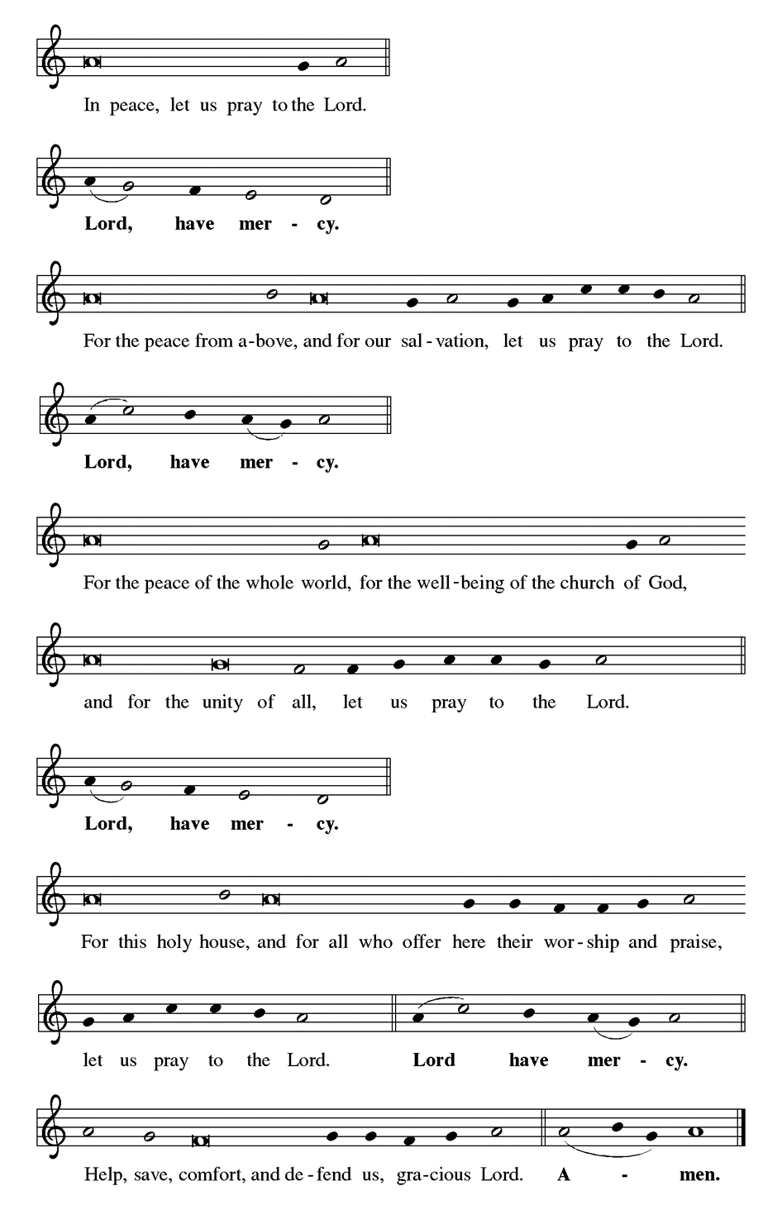
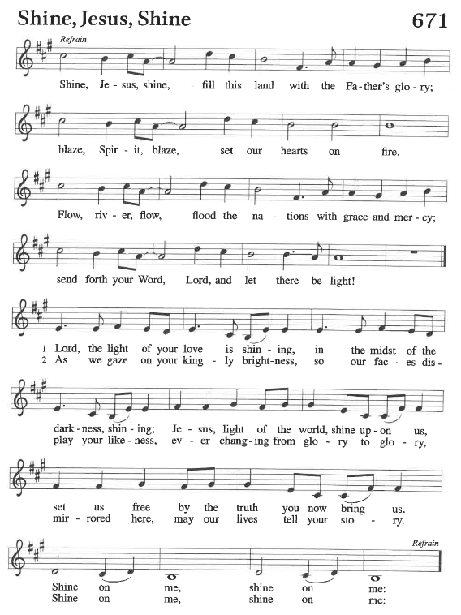

IN OUR PRAYERS THIS WEEK – JANUARY 16, 2022
Cathleen Dahl, Charlie Parks, William Panick, Bob Keener, Susan and David Friend, Maureen Caldwell, April Kennedy, Andy and June Harnack, John Bennett, Sarah Lanier, Catherine Campbell, Bill Tidwell, Charlie Norman, Kay Pedrotti, Marilyn and Russ Rines, Kathy Gates.

birthdays EXPECTANT PARENTS
1/16 Peter Droegmiller Heather and Marcus Loner
1/20 Owen Park Molly and Justin Day
1/20 Sarah Sanders
MILITARY
Sequoya McLendon, Chantz Roche

Family and Friends: Liz and Bob Sherliza, Deb Tutson, Claudette Gallman, (Friends of Saint John); Jennifer Jones and Kyle (friends of Amy Droegmiller), Haley Olinger (friend of Terry Emlet);Ruby Reid (family of Gwen Flowers-Taylor); Brian and Shiy (family of Steve and Sandra Harwood); Charles Harper, Tim Kennedy (family and friends of April Kennedy); Nancy Osteen, family of Joel Puzder (friends of Janet Kindred); Kim Lothrop, (family of Connie Klopfenstein); Brian, Susan St. John, Deborah Lanier, John Carr, Scott and Kimberly Lanier (family and friends of Sarah Lanier); Isaac Russell (family of Marcus Loner); Richard and Sue Tomsovic, (Uncle & Aunt of Tish Martin); Melissa Roy, Mary Donna Harris (family of Jill Roy); Doug Maxwell, (Brother of Debbie Sakmar); Whitney O’Connor Hawk (granddaughter of Larry Schultz); Helen Carter (family of Peggy Thomas), Jeanie Tidwell (mother of Bill, Tidwell); Jennifer and Bobby Mooneyham (parents of Tina Venus), Ron and Kathy Ballek (brother and sister-in-law of Sharon Willard).

MASKS
While masks are not required in the building, we strongly urge you to wear one. We also ask that you maintain social distancing.

BIBLE STUDY, SUNDAYS AT 3:30 PM
We will discuss Session 3 in the Love booklet. If you are not receiving the zoom instructions or the weekly newsletter, and would like to, please call Lynn Jones in the office and let her know.

BAGS NEEDED
Plastic grocery bags are needed for the mat weaving class. If you have extra bags, please consider donating them. We are especially looking for colorful bags, but will take any color. All mats are donated to the homeless.

NOISY CHANGE BUCKET
Noisy change for January will go for the Lutheran relief efforts in Kentucky, & Tennessee.

CenterING Prayer
Centering prayer in person is being postponed. Out of an abundance of caution, and with the positivity rate at a high for Covid testing in the area, meeting in person is put on hold for the next several weeks. Pastor Mary and Gary Larson will talk and will share more information for returning to an in-person meeting by the end of January. Thanks for your patience as we make our way through this time looking out for each other.

Annual Meeting, Part 2, January 23, 11:30 am
We will receive the annual reports of our officers and committees and celebrate our ministry in 2021. Officers and committee chairs, please have reports turned in to Lynn Jones by Sunday, January 16.

Daily Readings
Monday: Psalm 145, Isaiah 54:1-8, Romans 12:9-21
Tuesday: Psalm 145, Song of Solomon 4:1-8, 1 Corinthians 1:3-17
Wednesday: Psalm 145, Song of Solomon 4:9—5:1, Luke 5:33-39
Thursday: Psalm 19, Isaiah 61:1-7, Romans 7:1-6
Friday: Psalm 19, Nehemiah 2:1-10, Romans 12:1-8
Saturday: Psalm 19, Nehemiah 5:1-13, Luke 2:39-52
Third Sunday after Epiphany: Nehemiah 8:1-3, 5-6, 8-10, Psalm 19,
1 Corinthians 12:12-31a, Luke 4:14-21

January 2022 Pastor’s Column

“Do not be anxious about anything, but in every situation, by prayer and petition, with thanksgiving, present your requests to God. And the peace of God, which passes all understanding, will guard your hearts and your minds in Christ Jesus.” Phil. 4:6-7

Happy New Year! Wait, what? We are still dealing with Covid? Life is still a bit precarious? Yes, it is a new year. Yes, we are still dealing with Covid, and yes, life is still precarious. So, how do we make our way through this time?

I always find January to be a bit of a let down once New Year’s Day is over, because it is often a dark, cold month. While I take a look at the year past and look forward to the new year, I find that I can sink into seasonal depression. I do not joke about this, because I have suffered through it during many winters. Seasonal Affect Disorder (SAD) affects around 11 million people each winter, and an estimated 25 million people experience winter blues. It is a reality for many people. There is help out there, and I can point you in the direction if you need it. A light box on my table has helped me greatly in the winter.

I always find that I need to prepare myself for winter, even in the south. So I draw upon these words of scripture that remind me to not be anxious about anything but by prayer and petition to present my requests to God. There is a lot to request right now to you, dear God: friends fighting Covid, others fighting cancer or depression, injustice in the world, families dealing with addiction, squabbles and complaints. The list goes on and on.

But then I see the word “thanksgiving.” It reminds me to take stock every day and to find three things to be thankful for. They can be as simple as getting out of bed with no pain to enjoying a great meal with my family. Studies find that when we give thanks and write down those things, it makes a huge difference in our attitude towards life. My college friend Chris reminded others today (on Facebook) of the gratitude jar. A gratitude jar is a container that you put slips of paper in with things that you are grateful for each day. Chris suggests that you write the date on the slip of paper (and she says it works better if you keep a pen and slips of paper by it) and what you are thankful for. Then at the end of the year, you read through all of your slips of paper. Now, this is something I am going to try this year. Whatever you decide to do and wherever you are in your walk of faith, know that God is with you in all that today brings and whatever tomorrow holds. I pray most of all that we will all seek to love and serve God fervently this coming year.

Saint John Lutheran Church
1689 Martin Luther King Jr. Parkway
Griffin, GA 30224
Church Phone: 770-228-0662
Email: stjohnelca@bellsouth.net
Website: www.stjohngriffin.org
Facebook: Saint John Evangelical Lutheran Church
Pastor Mary Armstrong-Reiner
Pastor_st.john@yahoo.com
Cell 309-212-0888

Support Staff
Lynn Jones, Administrative Assistant Amy Droegmiller, Youth Leader
Marilyn Droegmiller, Organist Gayle Harvil, Praise Team Director
Joan Thomas, Interim Music Coordinator Heather Loner, Nursery Attendant
Jennifer Durham, Choir Accompanist

Congregation Council
Don Taylor, President Todd Droegmiller Catherine Park
Russ Rines, Vice-President Bailey Harvil-Sevier Sarah Sanders
Vaughn Maples, Secretary Donna Milam
Tish Martin, Treasurer Enid Mswia
Phyllis Hutchings, Financial Secretary

Ministry Contacts
Altar Guild: Sandra Harwood Member Care: Sarah Lanier, Cheryl Maples
Education: Phyllis Hutchings Property: John Sanders
Fellowship: Laura Miller, Martha Dansby Social Ministry: Jill Gates, Don Taylor
Finance: Tish Martin, Phyllis Hutchings Stewardship: Mark Miller
Gifts and Memorials: Tish Martin Worship: Sandra Harwood
Glocal Mission: Larry Schultz Youth/Children’s Ministry: Amy Droegmiller

All liturgies, prayers, Bible passages and music are reprinted with permission from the following resources.
Augsburg Fortress Liturgies Annual License 23384;
OneLicense.net. License #A-701923; CCLI License # 2725291 & 20964660.
OneLicense.net. License #A-701923; CCLI License # 2725291.

