Saint John Lutheran Church

We trust God and invite you to experience God’s inclusive love!

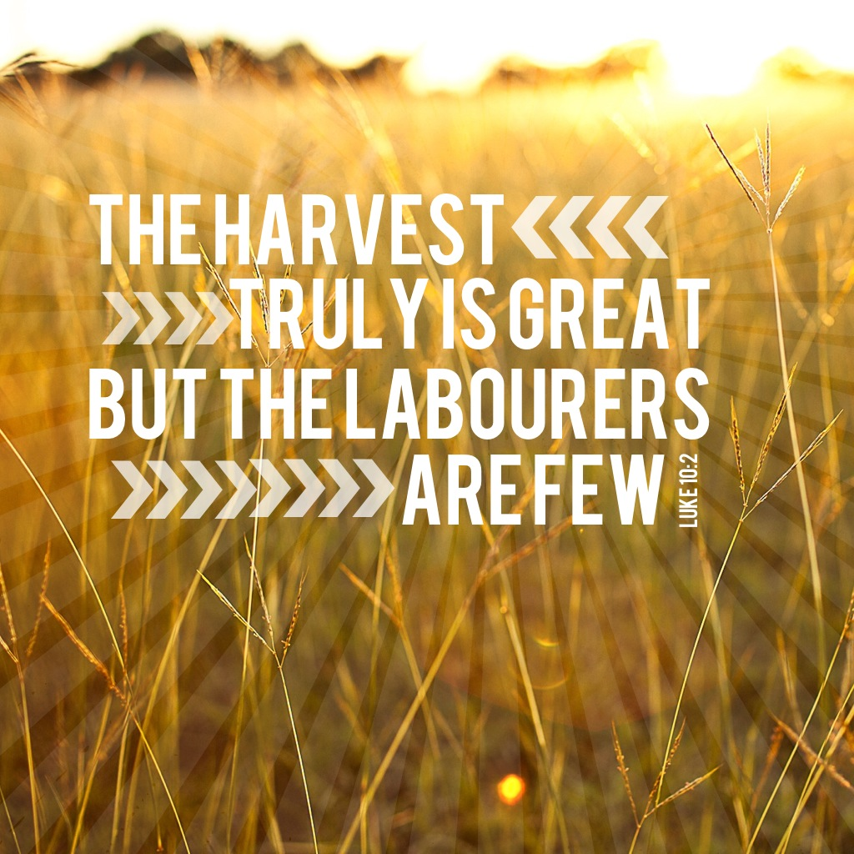

Fourth Sunday after Pentecost
July 3, 2022 10:00 A.M.
SCHEDULE FOR THE WEEK OF JULY 3

Sunday, July 3 Fourth Sunday after Pentecost
10:00 am Worship (Online Only)
5:30 pm AA Primary Purpose

Monday, July 4 Office Closed
7:00 pm AA Primary Purpose
7:00 pm Easy Does It Al-Anon

Tuesday, July 5 Office Closed
7:00 pm AA Primary Purpose

Wednesday, July 6 No Services or activities

Thursday, July 7 10:00 am Mat Weaving

Saturday, July 9 8:30 am AA District
5:30 pm AA Primary Purpose

Sunday, July 10 Fifth Sunday after Pentecost
10:00 am Worship
5:30 pm AA Primary Purpose

Serving Saints
Reader: Julie Gates
GATHERING

Prelude

Welcome

Please stand

Prayer of Preparation
We come this morning giving thanks for the freedom to worship God as we wish.
We thank you God

We praise you God for the many blessings of our life, and we pray to work for justice and freedom, liberty and truth for all in this land.
We Praise you loving God

We thank you for all who have & continue to work to build our communities, for our farmers who grow our food, for teachers and artists, health workers, and grocery clerks, and for all who make up the great fabric of our county.
We thank you dear God

We pray that we will never take life and Liberty for granted, and that we will support all people in your world who seek to live as free people.
God hear our prayer

May we never take for granted our faith, which guides our lives, and May we always seek to share your love, grace, and mercy with those we meet in our daily walk of life. We ask this in your precious son’s name, Jesus, our savior. Amen

Our mission here at St. John is…
We trust God and invite you to experience God’s inclusive Love!

Gathering Song Come, All You People #819

Greeting
The grace of our Lord Jesus Christ, the love of God, and the Communion of the Holy Spirit be with you all. And also with you.

The Prayer of the Day
O God, the Father of our Lord Jesus, you are the city that shelters us, the mother who comforts us. With your Spirit accompany us on our life’s journey, that we may spread your peace in all the world, through your Son, Jesus Christ, our Savior and Lord. Amen.

WORD

Isaiah 66:10-14
¹⁰Rejoice with Jerusalem, and be glad for her,
all you who love her;
rejoice with her in joy,
all you who mourn over her—
¹¹that you may nurse and be satisfied
from her consoling breast;
that you may drink deeply with delight
from her glorious bosom.
¹²For thus says the Lord:
I will extend prosperity to her like a river,
and the wealth of the nations like an overflowing stream;
and you shall nurse and be carried on her arm,
and dandled on her knees.
¹³As a mother comforts her child,
so I will comfort you;
you shall be comforted in Jerusalem.
¹⁴You shall see, and your heart shall rejoice;
your bodies shall flourish like the grass;
and it shall be known that the hand of the Lord is with his servants,
and his indignation is against his enemies.

Word of God, word of life. Thanks be to God

Psalm 66:1-9
¹Be joyful in God, all you lands;
be joyful, all the earth.
²Sing the glory of God’s name;
sing the glory of God’s praise.
³Say to God, “How awesome are your deeds!
Because of your great strength your enemies cringe before you.
⁴All the earth bows down before you,
sings to you, sings out your name.”
⁵Come now and see the works of God,
how awesome are God’s deeds toward all people.
⁶God turned the sea into dry land, so that they went through the water on foot,
and there we rejoiced in God.
⁷Ruling forever in might, God keeps watch over the nations;
let no rebels exalt themselves.
⁸Bless our God, you peoples;
let the sound of praise be heard.
⁹Our God has kept us among the living
and has not allowed our feet to slip.

Galatians 6:[1-6] 7-16
[¹My friends, if anyone is detected in a transgression, you who have received the Spirit should restore such a one in a spirit of gentleness. Take care that you yourselves are not tempted. ²Bear one another’s burdens, and in this way you will fulfill the law of Christ. ³For if those who are nothing think they are something, they deceive themselves. ⁴All must test their own work; then that work, rather than their neighbor’s work, will become a cause for pride. ⁵For all must carry their own loads.
⁶Those who are taught the word must share in all good things with their teacher.]
⁷Do not be deceived; God is not mocked, for you reap whatever you sow. ⁸If you sow to your own flesh, you will reap corruption from the flesh; but if you sow to the Spirit, you will reap eternal life from the Spirit. ⁹So let us not grow weary in doing what is right, for we will reap at harvest time, if we do not give up. ¹⁰So then, whenever we have an opportunity, let us work for the good of all, and especially for those of the family of faith. ¹¹See what large letters I make when I am writing in my own hand! ¹²It is those who want to make a good showing in the flesh that try to compel you to be circumcised—only that they may not be persecuted for the cross of Christ. ¹³Even the circumcised do not themselves obey the law, but they want you to be circumcised so that they may boast about your flesh.
¹⁴May I never boast of anything except the cross of our Lord Jesus Christ, by which the world has been crucified to me, and I to the world. ¹⁵For neither circumcision nor uncircumcision is anything; but a new creation is everything! ¹⁶As for those who will follow this rule—peace be upon them, and mercy, and upon the Israel of God.
Word of God, word of life. Thanks be to God.

The Holy Gospel according to Luke. Glory to you, O Lord.

Luke 10:1-11, 16-20
¹After this the Lord appointed seventy others and sent them on ahead of him in pairs to every town and place where he himself intended to go. ²He said to them, “The harvest is plentiful, but the laborers are few; therefore ask the Lord of the harvest to send out laborers into his harvest. ³Go on your way. See, I am sending you out like lambs into the midst of wolves. ⁴Carry no purse, no bag, no sandals; and greet no one on the road. ⁵Whatever house you enter, first say, ‘Peace to this house!’ ⁶And if anyone is there who shares in peace, your peace will rest on that person; but if not, it will return to you. ⁷Remain in the same house, eating and drinking whatever they provide, for the laborer deserves to be paid. Do not move about from house to house. ⁸Whenever you enter a town and its people welcome you, eat what is set before you; ⁹cure the sick who are there, and say to them, ‘The kingdom of God has come near to you.’ ¹⁰But whenever you enter a town and they do not welcome you, go out into its streets and say, ¹¹‘Even the dust of your town that clings to our feet, we wipe off in protest against you. Yet know this: the kingdom of God has come near.’ ” ¹⁶“Whoever listens to you listens to me, and whoever rejects you rejects me, and whoever rejects me rejects the one who sent me.” ¹⁷The seventy returned with joy, saying, “Lord, in your name even the demons submit to us!” ¹⁸He said to them, “I watched Satan fall from heaven like a flash of lightning. ¹⁹See, I have given you authority to tread on snakes and scorpions, and over all the power of the enemy; and nothing will hurt you. ²⁰Nevertheless, do not rejoice at this, that the spirits submit to you, but rejoice that your names are written in heaven.”

The Gospel of the Lord. Praise to you, O Christ.

Sermon

Silence is kept for reflection

Hymn of the Day Will You Come and Follow Me #798

Apostles’ Creed
I believe in God, the Father almighty,
creator of heaven and earth.

I believe in Jesus Christ, God’s only Son, our Lord,
who was conceived by the Holy Spirit,
born of the virgin Mary,
suffered under Pontius Pilate,
was crucified, died, and was buried;
he descended to the dead.
On the third day he rose again;
he ascended into heaven,
he is seated at the right hand of the Father,
and he will come to judge the living and the dead.

I believe in the Holy Spirit,
the holy catholic Church,
the communion of saints,
the forgiveness of sins,
the resurrection of the body,
and the life everlasting. Amen

Prayers of Intercession
United in Christ and guided by the Spirit, we pray for the church, the creation, and all in need.

A brief silence.

Lord of the harvest, you send your church into the world to proclaim Christ’s new creation to all. Renew the church as it carries out your mission of peace and healing. We pray for missionaries who accompany your people. Bless the ministry of Agustinian Lutheran School, Guatemala and St. Johannes, Bavaria. We pray for Grace Missions and Chez Moi Orphanage, Haiti. God of grace, hear our prayer.

Your creation abounds with flowing waters and diverse creatures. Guide the work of climate scientists as they develop and advocate ways to restore earth’s natural balance. Motivate humankind to adopt lifestyles that protect and sustain the earth. God of grace, hear our prayer.

Protect first responders and military personnel especially, Chantz Roche, Sequoya McLendon, who risk their lives in service of others.
God of grace, hear our prayer.

Mothering God, you care for all people in need. Nourish those who are hungry. Restore employment to those who have lost work. Heal those who are sick, and comfort all who are dying or grieving especially, Cathleen Dahl, Charlie Parks, William Panick, Bob Keener, Susan and David Friend, Maureen Caldwell, April Kennedy, Andy and June Harnack, John Bennett, Sarah Lanier, Catherine Campbell, Kay Pedrotti, Janet Kindred, Debbie Sakmar, Alan Tuffarella.
God of grace, hear our prayer.

We pray for this assembly and ask your blessings and guidance over the lives of those who are celebrating birthdays, Gretchen Ahrens, Russ Rines.
God of grace, hear our prayer.

We lift up all others we name in our hearts or on our lips….. (Pause)
God of grace, hear our prayer.

God of every time and place, in Jesus’ name and filled with your Holy Spirit, we entrust these spoken prayers and those in our hearts into your holy keeping. Amen.

THANKSGIVING

Please sit

Gathering of Gifts

Offertory

Special Music I’ll Do My Best Droegmiller Family

Thanksgiving for the Word
Let us pray.
Praise and thanks to you, holy God, for by your Word you made all things: you spoke light into darkness, called forth beauty from chaos, and brought life into being. For your Word of life, O God, we give you thanks and praise.

By your Word you called your people Israel to tell of your wonderful gifts: freedom from captivity, water on the desert journey, a pathway home from exile, wisdom for life with you. For your Word of life, O God,
we give you thanks and praise.

Through Jesus, your Word made flesh, you speak to us and call us to witness: forgiveness through the cross, life to those entombed by death, the way of your self-giving love. For your Word of life, O God, we give you thanks and praise.

Send your Spirit of truth, O God; rekindle your gifts within us: renew our faith, increase our hope, and deepen our love, for the sake of a world in need. Faithful to your Word, O God, draw near to all who call on you; through Jesus Christ, our Savior and Lord, to whom, with you and the Holy Spirit, be honor and glory forever. Amen.

Lord, remember us in your kingdom and teach us to pray:
Our Father, who art in heaven,
hallowed be thy name,
thy kingdom come, thy will be done,
on earth as it is in heaven.
Give us this day our daily bread;
and forgive us our trespasses,
as we forgive those who trespass against us;
and lead us not into temptation, but deliver us from evil.
For thine is the kingdom,
and the power, and the glory,
forever and ever. Amen

SENDING

Benediction
The God of peace, Father, ☩ Son, and Holy Spirit, bless you, comfort you,
and show you the path of life this day and always. Amen.

Sending Hymn Lord, Dismiss Us with Your Blessing #545

Dismissal
As we go on our way, let us remember…
Through Jesus Christ, we are an equipping and responding church
that continues to grow, impact, and transform lives.
Go in Peace, May the Holy Spirit guide you. Thanks be to God!

Postlude

IN OUR PRAYERS THIS WEEK – JULY 3, 2022
Cathleen Dahl, Charlie Parks, William Panick, Bob Keener, Susan and David Friend, Maureen Caldwell, April Kennedy, Andy and June Harnack, John Bennett, Sarah Lanier, Catherine Campbell, Kay Pedrotti, Debbie Sakmar, Janet Kindred.

BIRTHDAYS MILITARY
7/5 Gretchen Ahrens Sequoya McLendon, Chantz Roche
7/6 Russ Rines

Family and Friends: Liz and Bob Sherliza, Deb Tutson (Friends of Saint John); Margaret Thompson (friend of Elaine Bell and Donna Milam); Rick Connor (friends of Gates); Patricia Freeman (mother of Gayle Harvil), Bruce Harwood (father of Steve Harwood); Charles Harper, Tim Kennedy (family and friends of April Kennedy); Patsy Slagle (friend of Janet Kindred, Gayle Harvil, Marilyn Droegmiller), Susan St. John, Scott Lanier (family and friends of Sarah Lanier); Isaac Russell (family of Marcus Loner); Rick Thacker, Brenda Evans (friends of Cheryl and Vaughn Maples); Sue Tomsovic (Aunt of Tish Martin); John Burger, Dana Burger, family of Bart Bartlett (friends and family of Bonnie Nichols). Melissa Roy, Donna Harris (family of Jill Roy); Doug Maxwell, (Brother of Debbie Sakmar); Whitney O’Connor Hawk (granddaughter of Larry Schultz); Ricky Bradford (cousin of Peggy Thomas), Jeanie Tidwell (mother of Bill Tidwell); Jennifer and Bobby Mooneyham (parents of Tina Venus), Ron and Kathy Ballek (brother and sister-in-law of Sharon Willard).

Wednesday night supper, 5:45 pm
Please join us for supper on Wednesdays in the fellowship hall.

BIBLE STUDY, SUNDAYS AT 3:30 PM VIA ZOOM
Next meeting will be July 10th. Have a great holiday!

BAGS NEEDED
Plastic grocery bags are needed for the mat weaving class. We are especially looking for colorful bags, but will take any color. All mats are donated to the homeless.

Daily Readings
Monday: Psalm 119:73-80, Jeremiah 6:10-19, Acts 19:21-27
Tuesday: Psalm 119:73-80, Jeremiah 8:4-13, Acts 19:28-41
Wednesday: Psalm 119:73-80, Joshua 23:1-16, Luke 10:13-16
Thursday: Psalm 25:1-10, Genesis 41:14-36, James 2:14-26
Friday: Psalm 25:1-10, Genesis 41:37-49, Acts 7:9-16
Saturday: Psalm 25:1-10, Leviticus 19:1-4, 32-37, John 3:16-21
Fifth Sunday after Pentecost: Deuteronomy 30:9-14, Psalm 25:1-10,
Colossians 1:1-14, Luke 10:25-37
Saint John Lutheran Church
1689 Martin Luther King Jr. Parkway
Griffin, GA 30224
Church Phone: 770-228-0662
Email: stjohnelca@bellsouth.net
Website: www.stjohngriffin.org
Facebook: Saint John Evangelical Lutheran Church

Support Staff
Lynn Jones, Administrative Assistant Amy Droegmiller, Youth Leader
Marilyn Droegmiller, Organist Gayle Harvil, Praise Team Director
Jennifer Durham, Choir Accompanist Heather Loner, Nursery Attendant

Congregation Council
Don Taylor, President Todd Droegmiller Catherine Park
Russ Rines, Vice-President Bailey Harvil-Sevier Sarah Sanders
Vaughn Maples, Secretary Donna Milam
Tish Martin, Treasurer Enid Mswia
Phyllis Hutchings, Financial Secretary

Ministry Contacts
Altar Guild: Sandra Harwood Member Care: Sarah Lanier, Cheryl Maples
Education: Phyllis Hutchings Property: John Sanders, Tish Martin
Fellowship: Laura Miller, Martha Dansby Social Ministry: Jill Gates, Don Taylor
Finance: Tish Martin, Phyllis Hutchings Stewardship: Mark Miller
Gifts and Memorials: Tish Martin Worship: Sandra Harwood
Glocal Mission: Larry Schultz Youth/Children’s Ministry: Amy Droegmiller

All liturgies, prayers, Bible passages and music are reprinted with permission from the following resources.
Augsburg Fortress Liturgies Annual License 23384;
OneLicense.net. License #A-701923; CCLI License # 2725291 & 20964660.
OneLicense.net. License #A-701923; CCLI License # 2725291.

