Saint John Lutheran Church

We trust God and invite you to experience God’s inclusive love!

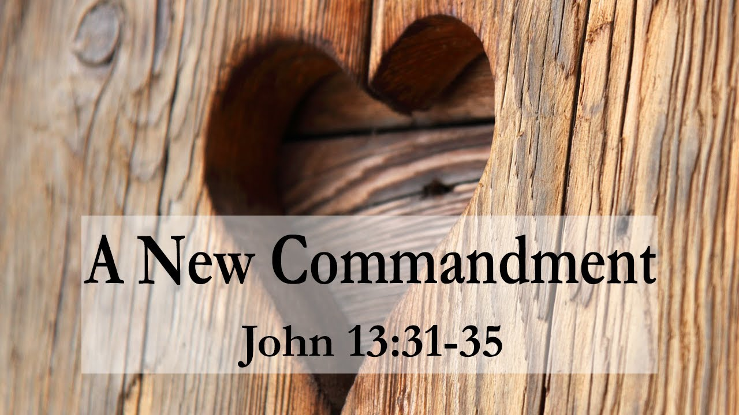

Fifth Sunday of Easter
May 15, 2022 10:00 A.M.

SCHEDULE FOR THE WEEK OF MAY 15

Sunday, May 15 Fifth Sunday of Easter
10:00 am Worship
11:15 am Drive-by Communion
11:30 am Coffee Hour
3:30 pm Online Bible Study with Jill Roy
5:30 pm AA Primary Purpose

Monday, May 16 Office Closed
7:00 pm AA Primary Purpose
7:00 pm Easy Does It Al-Anon

Tuesday, May 17 10:30 am Centering Prayer
12:30 pm Theology on Tap
7:00 pm AA Primary Purpose

Wednesday, May 18 5:45 pm Supper
6:30 pm Wednesday Night Worship
7:30 pm Choir Practice

Thursday, May 19 10:00 am Mat Weaving

Saturday, May 21 5:30 pm AA Primary Purpose

Sunday, May 22 Sixth Sunday of Easter
10:00 am Worship
11:15 am Drive-by Communion
11:30 am Coffee Hour
3:30 pm Online Bible Study with Jill Roy
5:30 pm AA Primary Purpose

Serving Saints
Reader: Julie Gates
Altar Guild: Sandra Harwood
Ushers: Harry and Sharon Willard
Stewards: Enid Mswia and Rita Johnson
GATHERING

Prelude

As we enter holy space and time, please silence your cell phones and enter quietly and reverently.

Welcome
Welcome! The Holy Spirit calls us together as the people of God.

Thanksgiving for Baptism
All may make the sign of the cross, the sign that is marked at baptism, as the presiding minister begins.

Alleluia! Christ is risen. Christ is risen indeed. Alleluia!

In the waters of baptism, we have passed over from death to life with Jesus Christ, and we are a new creation. For this saving mystery, and for this water, let us bless God, who was, who is, and who is to come.

Water may be poured into the font as the presiding minister gives thanks.

We thank you, God, for your river of life, flowing freely from your throne:
through the earth, through the city, through every living thing.

You rescued Noah and his family from the flood; You opened wide the sea for the Israelites. Now in these waters you flood us with mercy, and our sin is drowned forever. You open the gate of righteousness and we pass safely through.

In Jesus Christ, you calm and trouble the waters. You nourish us and enclose us in safety. You call us forth and send us out. In lush and barren places, you are with us. You have become our salvation.

Now breathe upon this water and awaken your church once more. Claim us again as your beloved and holy people. Quench our thirst; cleanse our hearts; wipe away every tear.

To you, our Beginning and our End, our Shepherd and Lamb, be honor, glory, praise, and thanksgiving, now and forever. Amen.

Our mission here at St. John is…
We trust God and invite you to experience God’s inclusive Love!

Gathering Song Now All the Vault of Heaven Resounds #367

Greeting
The presiding minister and the people greet each other and pray.
The grace of our Lord Jesus Christ, the love of God, and the Communion of the Holy Spirit be with you all. And also with you.

Hymn of Praise This is the feast p.169

The Prayer of the Day
Lord God, you teach us that without love, our actions gain nothing. Pour into our hearts your most excellent gift of love, that, made alive by your Spirit, we may know goodness and peace, through your Son, Jesus Christ, our Savior and Lord, who lives and reigns with you and the Holy Spirit, one God, now and forever. Amen.

WORD
God speaks to us in scripture readings, preaching and song. The first reading is usually from the Old Testament. The psalms are ancient songs of faith. The second reading, usually from the New Testament letters, gives the witness of the early church.

Acts 11:1-18
¹Now the apostles and the believers who were in Judea heard that the Gentiles had also accepted the word of God. ²So when Peter went up to Jerusalem, the circumcised believers criticized him, ³saying, “Why did you go to uncircumcised men and eat with them?” ⁴Then Peter began to explain it to them, step by step, saying, ⁵“I was in the city of Joppa praying, and in a trance I saw a vision. There was something like a large sheet coming down from heaven, being lowered by its four corners; and it came close to me. ⁶As I looked at it closely I saw four-footed animals, beasts of prey, reptiles, and birds of the air. ⁷I also heard a voice saying to me, ‘Get up, Peter; kill and eat.’ ⁸But I replied, ‘By no means, Lord; for nothing profane or unclean has ever entered my mouth.’ ⁹But a second time the voice answered from heaven, ‘What God has made clean, you must not call profane.’ ¹⁰This happened three times; then everything was pulled up again to heaven. ¹¹At that very moment three men, sent to me from Caesarea, arrived at the house where we were. ¹²The Spirit told me to go with them and not to make a distinction between them and us. These six brothers also accompanied me, and we entered the man’s house. ¹³He told us how he had seen the angel standing in his house and saying, ‘Send to Joppa and bring Simon, who is called Peter; ¹⁴he will give you a message by which you and your entire household will be saved.’ ¹⁵And as I began to speak, the Holy Spirit fell upon them just as it had upon us at the beginning. ¹⁶And I remembered the word of the Lord, how he had said, ‘John baptized with water, but you will be baptized with the Holy Spirit.’
¹⁷If then God gave them the same gift that he gave us when we believed in the Lord Jesus Christ, who was I that I could hinder God?” ¹⁸When they heard this, they were silenced. And they praised God, saying, “Then God has given even to the Gentiles the repentance that leads to life.”

Word of God, word of life. Thanks be to God

Psalm 148
¹Hallelujah! Praise the Lord from the heavens;
praise God in the heights.
²Praise the Lord, all you angels;
sing praise, all you hosts of heaven.
³Praise the Lord, sun and moon;
sing praise, all you shining stars.
⁴Praise the Lord, heaven of heavens,
and you waters above the heavens.
⁵Let them praise the name of the Lord,
who commanded, and they were created,
⁶who made them stand fast forever and ever,
giving them a law that shall not pass away.
⁷Praise the Lord from the earth,
you sea monsters and all deeps;
⁸fire and hail, snow and fog,
tempestuous wind, doing God’s will;
⁹mountains and all hills,
fruit trees and all cedars;
¹⁰wild beasts and all cattle,
creeping things and flying birds;
¹¹sovereigns of the earth and all peoples,
princes and all rulers of the world;
¹²young men and maidens,
old and young together.
¹³Let them praise the name of the Lord,
whose name only is exalted, whose splendor is over earth and heaven.
¹⁴The Lord has raised up strength for the people
and praise for all faithful servants,
the children of Israel, a people who are near the Lord. Hallelujah!

Revelation 21:1-6
¹I saw a new heaven and a new earth; for the first heaven and the first earth had passed away, and the sea was no more. ²And I saw the holy city, the new Jerusalem, coming down out of heaven from God, prepared as a bride adorned for her husband. ³And I heard a loud voice from the throne saying,
“See, the home of God is among mortals.
He will dwell with them;
they will be his peoples,
and God himself will be with them;
⁴he will wipe every tear from their eyes.
Death will be no more;
mourning and crying and pain will be no more,
for the first things have passed away.”
⁵And the one who was seated on the throne said, “See, I am making all things new.” Also he said, “Write this, for these words are trustworthy and true.” ⁶Then he said to me, “It is done! I am the Alpha and the Omega, the beginning and the end. To the thirsty I will give water as a gift from the spring of the water of life.”

Word of God, word of life. Thanks be to God

Gospel Acclamation 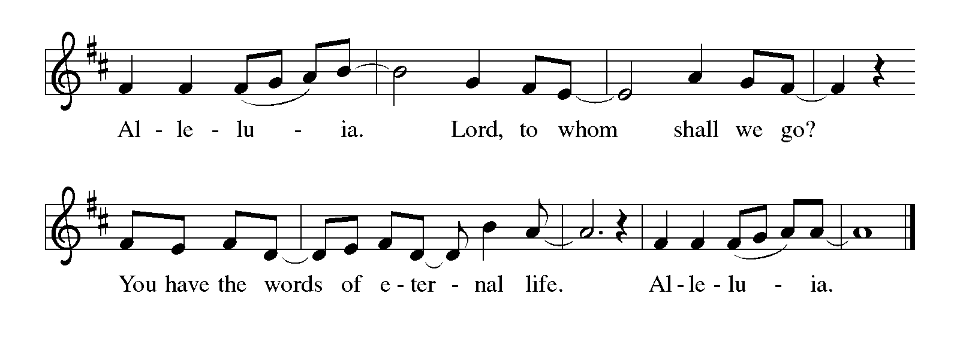
The gospel reading comes from one of the first four books of the New Testament that tell of Jesus’ ministry.

The Holy Gospel according to John. Glory to you, O Lord.

John 13:31-35
³¹When he had gone out, Jesus said, “Now the Son of Man has been glorified, and God has been glorified in him. ³²If God has been glorified in him, God will also glorify him in himself and will glorify him at once. ³³Little children, I am with you only a little longer. You will look for me; and as I said to the Jews so now I say to you, ‘Where I am going, you cannot come.’ ³⁴I give you a new commandment, that you love one another. Just as I have loved you, you also should love one another. ³⁵By this everyone will know that you are my disciples, if you have love for one another.”

The Gospel of the Lord. Praise to you, O Christ.

Sermon
Preaching connects God’s word of law and gospel to our time and place

Silence is kept for reflection

Hymn of the Day Alleluia! Sing to Jesus #392

Apostles’ Creed
I believe in God, the Father almighty,
creator of heaven and earth.

I believe in Jesus Christ, God’s only Son, our Lord,
who was conceived by the Holy Spirit,
born of the virgin Mary,
suffered under Pontius Pilate,
was crucified, died, and was buried;
he descended to the dead.
On the third day he rose again;
he ascended into heaven,
he is seated at the right hand of the Father,
and he will come to judge the living and the dead.

I believe in the Holy Spirit,
the holy catholic Church,
the communion of saints,
the forgiveness of sins,
the resurrection of the body,
and the life everlasting. Amen

God’s word is proclaimed as we sing and confess our faith. The creed is an ancient statement of faith. We pray for the needs of our church, our community, our world and ourselves; and we offer prayers of thanksgiving.

Prayers of Intercession
Set free from captivity to sin and death, we pray to the God of resurrection for the church, people in need, and all of creation.

A brief silence.

Loving God, lead us to follow your Spirit, rather than our own prejudices or desires, as the church cares for one another. Open us to perceive your gifts in those we least expect. Bless the ministry of our sister congregations: Agustinian Lutheran School, Guatemala and St. Johannes, Bavaria; Grace Missions and Chez Moi Orphanage, Haiti.
God, in your mercy, hear our prayer.

Humble the rulers of nations before your splendor. Direct them to the people who need their attention most, and turn them from the temptation to hoard wealth or power. Protect those serving in the military, especially Chantz Roche and Sequoya McLendon. God, in your mercy, hear our prayer.

Hasten to dwell among those who are in pain or distress especially, Cathleen Dahl, Charlie Parks, William Panick, Bob Keener, Susan and David Friend, Maureen Caldwell, April Kennedy, Andy and June Harnack, John Bennett, Sarah Lanier, Catherine Campbell, Charlie Norman and Connie Klopfenstein, Kay Pedrotti, Kathy Gates, Janet Kindred, Frank Dansby, Debbie Sakmar. As Christ enters our deepest suffering, remain with those experiencing despair and great need. God, in your mercy, hear our prayer.

Send blessings to those celebrating birthdays, John Roy, Peggy Thomas, Adam Miller, Sharon Willard; those celebrating anniversaries, Doug and Lynn Jones, Bill and Kathy Gates, Terry and Terry Emlet, Les and Bobbi Windsor.
God, in your mercy, hear our prayer.

Place holy love at the center of all our relationships and communities. By your love heal us, convict us, and renew us. Bring an end to racism in our churches and communities. Let everyone know your goodness by the love we show one another. God, in your mercy, hear our prayer.

Hear now the spoken and unspoken prayers of your people …...
God, in your mercy, hear our prayer.

Give us a place in the diverse company of your beloved saints. Teach us the value of each person’s identity, and bless us with a shared identity as your children, kindred of Christ. God, in your mercy, hear our prayer.

In your mercy, O God, respond to these prayers, and renew us by your life-giving Spirit; through Jesus Christ, our Savior. Amen.

MEAL
We receive and extend to one another the gift of Christ’s peace. A collection of material goods for the church’s mission is gathered as a sign of the giving of our whole selves in grateful response for all of God’s gifts. The table is set with bread and wine. A gift of music is offered, and prayers of thanksgiving are sung and spoken.

Gathering of Gifts

Choir

Offering Hymn Let the Vineyards Be Fruitful #183

Offering Prayer
Living God, you gather the wolf and the lamb to feed together in your peaceable reign, and you welcome us all at your table.
Reach out to us through this meal, and show us your wounded and risen body, that we may be nourished and believe in Jesus Christ, our Savior and Lord. Amen.

Before the Lord’s Supper is shared, the presiding minister leads us in a prayer of thanksgiving(Eucharist) to God for creation and salvation, remembrance of the crucified and risen Christ, and the Holy Spirit’s presence in this meal. The thanksgiving concludes with the prayer our Lord Jesus taught us.

The Great Thanksgiving
The Lord be with you.
And also with you.
Lift up your hearts.
We lift them to the Lord.
Let us give thanks to the Lord our God.
It is right to give our thanks and praise.

Preface for Easter
It is indeed right, our duty and our joy, that we should at all times and in all places give thanks and praise to you, almighty and merciful God, for the glorious resurrection of our Savior Jesus Christ, the true Paschal Lamb who gave himself to take away our sin; who in dying has destroyed death, and in rising has brought us to eternal life. And so, with Mary Magdalene and Peter and all the witnesses of the resurrection, with earth and sea and all their creatures, and with angels and archangels, cherubim and seraphim, we praise your name and join their unending hymn:

Holy, Holy, Holy 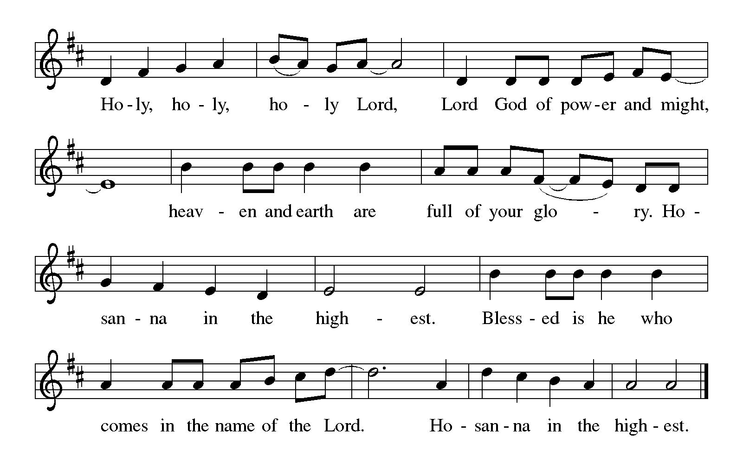

Eucharistic Prayer for Easter
Holy, living, and loving God,
we praise you for creating the heavens and the earth.
We bless you for bringing Noah and his family through the waters of the flood,
for freeing your people Israel from the bonds of slavery,
and for sending your Son to be our Redeemer.

We give you thanks for Jesus
who, living among us, healed the sick, fed the hungry,
and with a love stronger than death, gave his life for others.

In the night in which he was betrayed,
our Lord Jesus took bread, and gave thanks;
broke it, and gave it to his disciples, saying:
Take and eat; this is my body, given for you.
Do this for the remembrance of me.

Again, after supper, he took the cup, gave thanks,
and gave it for all to drink, saying:
This cup is the new covenant in my blood,
shed for you and for all people for the forgiveness of sin.
Do this for the remembrance of me.

Remembering, therefore,
his life-giving death and glorious resurrection,
we await your promised life for all this dying world.

Breathe your Spirit on us and on this bread and cup:
carry us in your arms from death to life,
that we may live as your chosen ones,
clothed in the righteousness of Christ.

Through him all glory and honor is yours,
Almighty Father, with the Holy Spirit,
in your holy Church, both now and forever.
Amen

Lord, remember us in your kingdom and teach us to pray:
Our Father, who art in heaven,
hallowed be thy name,
thy kingdom come, thy will be done,
on earth as it is in heaven.
Give us this day our daily bread;
and forgive us our trespasses,
as we forgive those who trespass against us;
and lead us not into temptation, but deliver us from evil.
For thine is the kingdom,
and the power, and the glory,
forever and ever. Amen
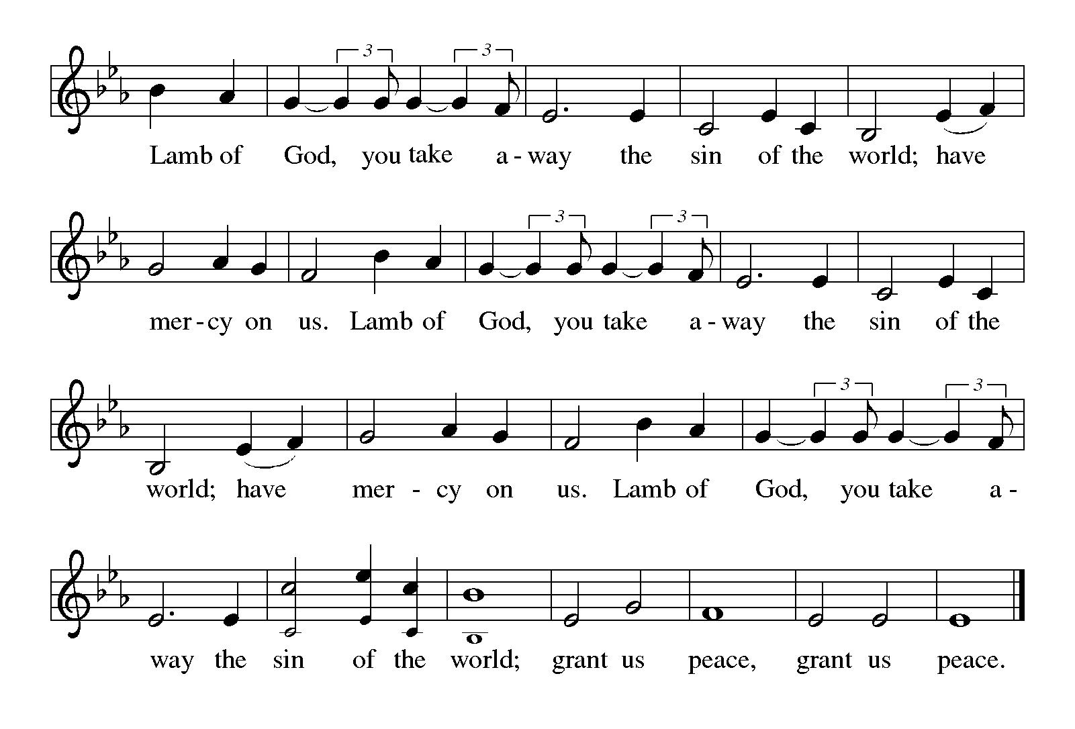
The congregation is encouraged to sing during the distribution:
By Your Hand You Feed Your People #469
Where Charity and Love Prevail #359

Table Blessing
The risen Christ dwells with us here.
All who are hungry, all who are thirsty, come.
Amen

Prayer after Communion
We give you thanks, generous God, for in this bread and cup we have tasted the new heaven and earth where hunger and thirst are no more. Send us from this table as witnesses to the resurrection, that through our lives, all may know life in Jesus’ name.
Amen.

Announcements
SENDING

God blesses us and sends us in mission to the world.

Benediction
God, the Author of life, Christ, the living Cornerstone, and the life-giving Spirit of adoption, ☩ bless you now and forever. Amen.

Instructions for final hymn given by Pastor Mary

Sending Hymn Christ Is Alive! Let Christians Sing #389

Dismissal
As we go on our way, let us remember…
Through Jesus Christ, we are an equipping and responding church
that continues to grow, impact, and transform lives.
Go in peace. Jesus meets you on the way.
Thanks be to God.

Postlude

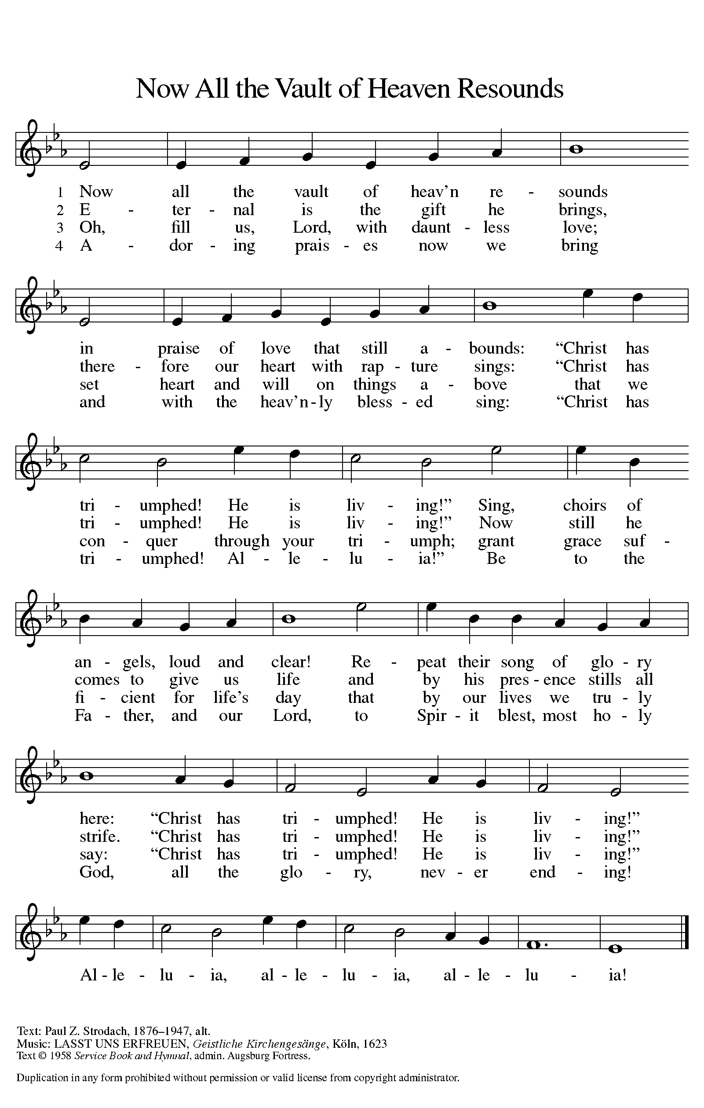
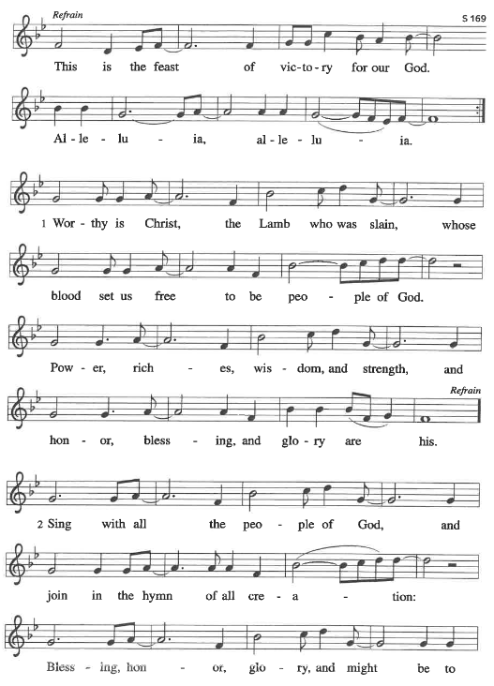

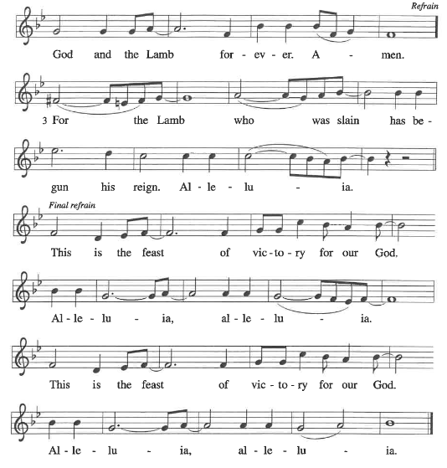

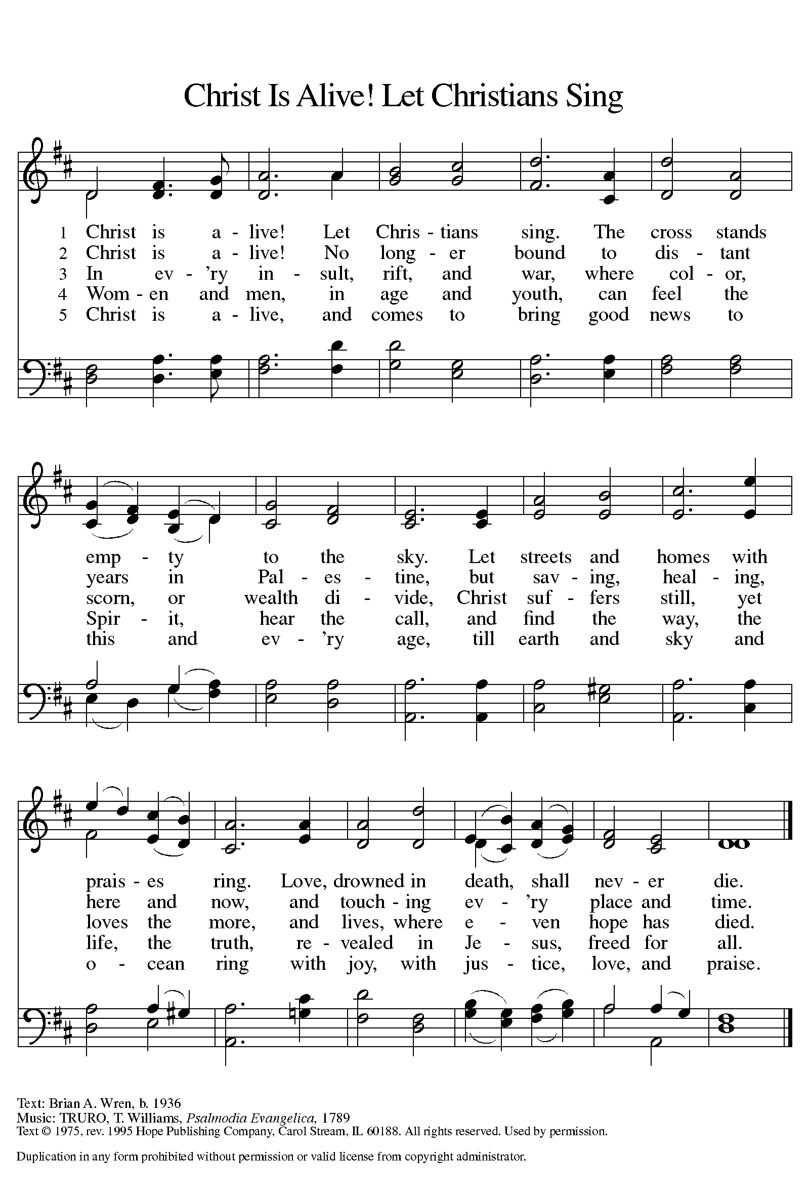

IN OUR PRAYERS THIS WEEK – MAY 15, 2022
Cathleen Dahl, Charlie Parks, William Panick, Bob Keener, Susan and David Friend, Maureen Caldwell, April Kennedy, Andy and June Harnack, John Bennett, Sarah Lanier, Catherine Campbell, Charlie Norman and Connie Klopfenstein, Kay Pedrotti, Kathy Gates, Janet Kindred, Frank Dansby, Debbie Sakmar.

BIRTHDAYS Anniversaries
5/17 John Roy 5/16 Doug and Lynn Jones
5/17 Peggy Thomas 5/18 Bill and Kathy Gates
5/18 Adam Miller 5/21 Terry and Terry Emlet
5/21 Sharon Willard 5/21 Les and Bobbi Windsor
MILITARY
Sequoya McLendon, Chantz Roche

Family and Friends: Liz and Bob Sherliza, Deb Tutson, (Friends of Saint John); Margaret Thompson (friend of Elaine Bell and Donna Milam); Bruce Harwood (father of Steve Harwood); Charles Harper, Tim Kennedy (family and friends of April Kennedy); Patsy Slagle (friend of Janet Kindred, Gayle Harvil, Marilyn Droegmiller), Susan St. John, Scott Lanier (family and friends of Sarah Lanier); Isaac Russell (family of Marcus Loner); Rick Thacker, Brenda Evans (friends of Cheryl and Vaughn Maples); Sue Tomsovic (Aunt of Tish Martin); John Burger, Dana Burger, family of Bart Bartlett (friends and family of Bonnie Nichols). Melissa Roy, Donna Harris (family of Jill Roy); Doug Maxwell, (Brother of Debbie Sakmar); Whitney O’Connor Hawk (granddaughter of Larry Schultz); Ricky Bradford (cousin of Peggy Thomas), Jeanie Tidwell (mother of Bill Tidwell); Jennifer and Bobby Mooneyham (parents of Tina Venus), Ron and Kathy Ballek (brother and sister-in-law of Sharon Willard).

BIBLE STUDY, SUNDAYS AT 3:30 PM VIA ZOOM
We hope that you will join this wonderful study group, led by Jill Roy. We are reading “Making Sense of the Cross”. Zoom instructions are sent out each week via email. If you are not receiving it and would like to, please let Lynn know.

Choir practice, wednesdays after Worship
Choir practice and planning after Wednesday night Worship. We hope you can join us!

Serving Saints needed
Now that we are back to normal activities, we are asking for volunteers to help with various jobs around the church. We are specifically asking for help with Altar Guild, Assisting Ministers, Coffee Hour and Fellowship Time. If you have any questions, please feel free to contact Lynn Jones in the office. Thank you for all your help!

you are invited
Pastor Mary and family would like to like to invite you to join them in celebration of Christopher’s High School graduation on May 21, 12-3pm at Epiphany Lutheran Church in Conyers. Lunch will be provided. No gifts are requested as your presence will be the gift to our family.

READERS NEEDED
If you can read/Speak another language, we would love to have you be part of our Pentecost Sunday reading of the Acts passage on Sunday June 5. Please sign the sheet in the narthex and share what language you speak. We would be happy to have several speaking the same language. So, please sign up! Pastor Mary will contact you the week before to go over the plan. Thank you!

Wednesday night supper, 5:45 pm
Please join us for supper on Wednesdays in the fellowship hall.

Theology on Tap, Tuesdays, 12:30 pm
We meet at Margo’s restaurant, 1136 W. Taylor St., Griffin.

The group is reading the book, “Julian of Norwich-Wisdom in a time of pandemic and beyond”. For any questions or more information, please talk to Gary Larson or Pastor Mary.

Centering Prayer, Tuesdays, 10:30 am
The group will begin with a time of silent meditation, and then spend time reading and discussing the book, “Faith after Doubt-Why your beliefs stopped working and what to do about it” by Brian McLaren.

BAGS NEEDED
Plastic grocery bags are needed for the mat weaving class. If you have extra bags, please consider donating them. We are especially looking for colorful bags, but will take any color. All mats are donated to the homeless.

ANNOUNCEMENTS
Just a reminder that all announcements need to be sent to Lynn Jones by Thursday morning for inclusion in the bulletin and newsletter that week. Thank you all for your help!

Daily Readings
Monday: Psalm 133, 1 Samuel 20:1-23, 35-42, Acts 11:19-26
Tuesday: Psalm 133, 2 Samuel 1:4-27, Acts 11:27-30
Wednesday: Psalm 133, Leviticus 19:9-18, Luke 10:25-28
Thursday: Psalm 67, Proverbs 2:1-5, Acts 15:36-41
Friday: Psalm 67, Proverbs 2:6-8, Acts 16:1-8
Saturday: Psalm 67, Proverbs 2:9-15, Luke 19:1-10
Sixth Sunday of Easter: Acts 16:9-15, Psalm 67,
Revelation 21:10, 22—22:5, John 14:23-29 or John 5:1-9

Saint John Lutheran Church
1689 Martin Luther King Jr. Parkway
Griffin, GA 30224
Church Phone: 770-228-0662
Email: stjohnelca@bellsouth.net
Website: www.stjohngriffin.org
Facebook: Saint John Evangelical Lutheran Church
Pastor Mary Armstrong-Reiner
Pastor_st.john@yahoo.com
Cell 309-212-0888

Support Staff
Lynn Jones, Administrative Assistant Amy Droegmiller, Youth Leader
Marilyn Droegmiller, Organist Gayle Harvil, Praise Team Director
Jennifer Durham, Choir Accompanist Heather Loner, Nursery Attendant

Congregation Council
Don Taylor, President Todd Droegmiller Catherine Park
Russ Rines, Vice-President Bailey Harvil-Sevier Sarah Sanders
Vaughn Maples, Secretary Donna Milam
Tish Martin, Treasurer Enid Mswia
Phyllis Hutchings, Financial Secretary

Ministry Contacts
Altar Guild: Sandra Harwood Member Care: Sarah Lanier, Cheryl Maples
Education: Phyllis Hutchings Property: John Sanders, Tish Martin
Fellowship: Laura Miller, Martha Dansby Social Ministry: Jill Gates, Don Taylor
Finance: Tish Martin, Phyllis Hutchings Stewardship: Mark Miller
Gifts and Memorials: Tish Martin Worship: Sandra Harwood
Glocal Mission: Larry Schultz Youth/Children’s Ministry: Amy Droegmiller

All liturgies, prayers, Bible passages and music are reprinted with permission from the following resources.
Augsburg Fortress Liturgies Annual License 23384;
OneLicense.net. License #A-701923; CCLI License # 2725291 & 20964660.
OneLicense.net. License #A-701923; CCLI License # 2725291.

